

Oruka initiates Phase 2 ORCA-SURGE trial of ORKA-002 (IL17A/F) in moderate-to-severe PsO
Company: Oruka  Drug: ORKA-002 (SC IL-17A/F inhibitor), ORKA-001 (SC IL-23p19 inhibitor) | Date: March 12th, 2026  Source(s): Press Release, Presentation

What happened:
- ORKA-002: Oruka announced the initiation in February of their Phase 2 ORCA-SURGE trial of ORKA-002 in adults with moderate-to-severe psoriasis (PsO) during their Q4 2025 earnings update (trial not listed yet on clinicaltrials.gov)
  - Topline data for ORCA-SURGE is anticipated in 2027
- ORKA-001: Phase 2a EVERLAST-A trial in PsO Wk16 PASI-100 data now expected in Q2 2026 (previously expected in 2H 2026) with long term data to follow in 2H 2026; enrollment completed in December 2025 due to “strong site engagement and enthusiasm”
  - Long-term EVERLAST-A data (Wk28 data and a portion of Wk52 follow-up) in H2 2026 – previously communicated as “response duration” only
  - ORKA-001 PsO Ph2b EVERLAST-B trial readouts is still listed as "2027" (no change from prior communication) – used to support initiation of Ph3 program

Impact (CI PoV): MEDIUM
- With this ORKA-002 Phase 2 trial initiation Oruka is moving into PsO as planned; trial initiation timing is in line with previous company guidance of H1 2026 and does not shift CI’s projected approval timelines
  - CI estimates earliest US and EU approval of ORKA-002 in PsO in Q2 2031
Why it matters:
- ORKA-002 targets the same dual cytokine epitopes (IL-17A/F) as Bimzelx but is anticipated to offer a significantly reduced injection burden with less frequent dosing; Oruka is proposing a two-maintenance dose per year paradigm for PsO which could differentiate ORKA-002 vs. Bimzelx’s Q8W maintenance dosing

Tell me more:
New trial details:
- Trial overview: ORCA-SURGE Phase 2 dose-ranging trial of ORKA-002 in moderate-to-severe PsO
- Enrollment: ~ 160 patients
- Primary endpoint: PASI 100 at W16
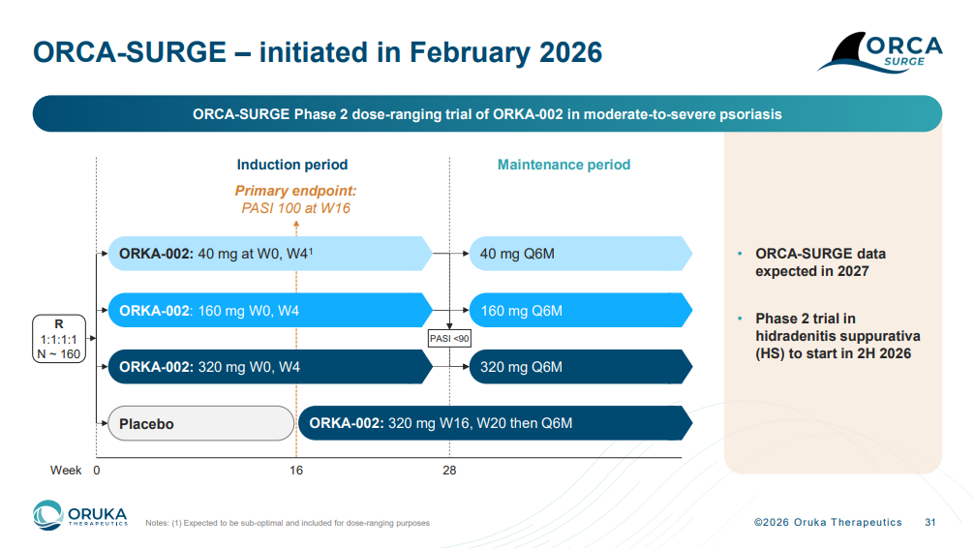

Additional details:
- Phase 2 ORCA-SURGE topline data expected in 2027 (in line with previous guidance)
- Phase 2 ORKA-002 trial in hidradenitis suppurativa (HS) is anticipated to start in H2 2026 (in line with previous guidance)
  - CI projects potential earliest US and EU approvals of ORKA-002 in HS in Q3 2031 and Q2 2031, respectively
- Oruka has $479.6 million in cash, cash equivalents and marketable securities providing runway >1 year beyond major readouts across EVERLAST-A, EVERLAST-B and ORCA-SURGE

For questions, please reach out to:
 | Dermatology | Rheumatology | Gastroenterology
APEX (US/PCS) | Chanda Bhat | Bethany Christmann | Luke Versten
IMABI (International/ Affiliates) | Priti Anand | Irene Knorn | Priti Anand

Invite your colleagues to inVision | Manage Email Preferences | Unsubscribe

This document contains competitive intelligence collected via AbbVie approved methods or vendors. We collect competitive intelligence consistent with industry standards and AbbVie policy. Not for commercial field use. Please reach out to CI, Legal or OEC with any questions.

